**High Performance Computing Lab**

**Practical No. 7**

**Name – Tushar Rathod**

**Batch – B7**

**PRN - 21510036**

**Title of practical:**

Installation of MPI & Implementation of basic functions of MPI

Installation -

It as simple as running a simple command on Terminal on My System which is Arch Based -

Command - “ sudo pacman –S openmpi ”

**Problem Statement 1:**

Implement a simple hello world program by setting number of processes equal to 10

**Screenshots:**

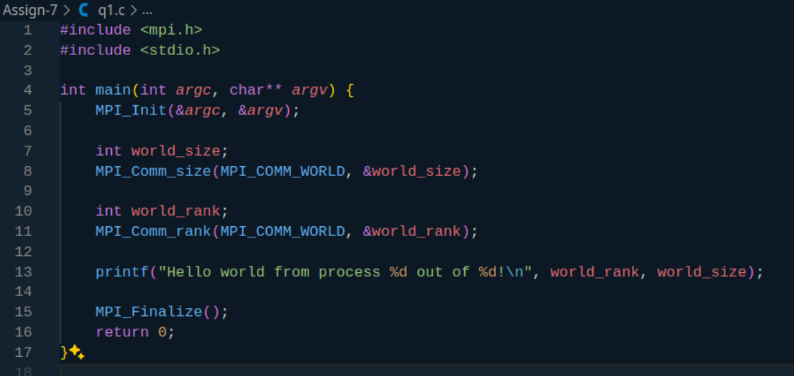

**Output -**

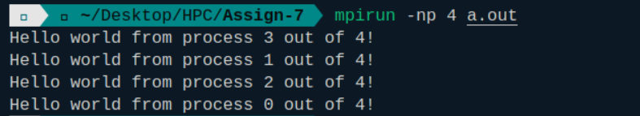

**Information 1:**

**Problem Statement 2:**

Implement a program to display rank and communicator group of five processes

**Screenshots:**

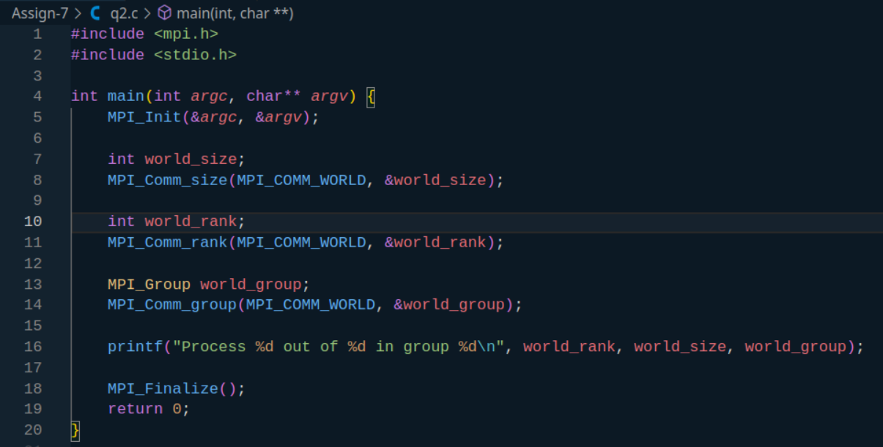

Output -

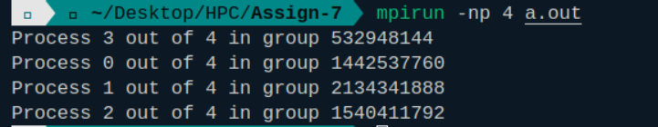

**Information:**